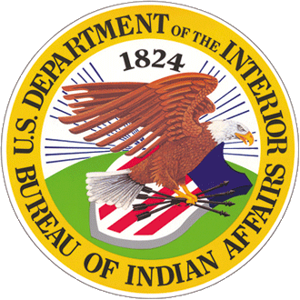
Bureau of Indian Affairs Now Hiring Student Trainee

Wildland Firefighter Positions
If you’re a student in high school, college, trade school or other qualifying educational institutions, the BIA Pathways Internship Program is for you! This program offers paid opportunities to work as a wildland firefighter for the Bureau of Indian Affairs or with a tribe to explore federal / tribal careers while completing your education.
Lists of minimum Education Requirements and Key Eligibility Requirements are here.

How to Apply
Starting February 9 through March 9, 2018, www.USAJOBS.gov will begin advertising BIA Student Trainee Wildland Firefighter positions. The duty stations for the positions are located throughout Indian Country, primarily in the western states.
Go directly to the job announcement at: https://www.usajobs.gov/GetJob/ViewDetails/491125400
or, find it and similar opportunities in USAJobs by selecting the Students & recent graduates filter, or the summer or seasonal appointment type filter in “search”. Your results will display all jobs open to Students and recent graduates.

Tips for Job Seekers
- Tips for writing a student resume and interview tips (PowerPoint)
- Example Resume for BIA Pathways Interns (docx)
- BIA Guide to Creating a Recent Graduate Federal Resume (pdf)

What do Fire Interns Do?
When starting, firefighters serve as a member of a fuels or wildland fire crew where they learn how to use specialized fire equipment such as engines and helicopters and how to work as a team to manage wildfires and remove hazardous fuels. Through this work, they get to know the wildland fire culture, develop leadership skills, and begin learning how fire is a tool to help manage the landscapes they restore and protect.

Participant Agreement
The incumbent is required to sign a participant agreement prior to selection. This Agreement provides a condition of employment and up-front awareness to a selectee that the official duty location of the position may change, depending on agency needs, funding, and other unforeseeable conditions that arise at the time of initial appointment but that could factor into permanent placement at a later period of employment.

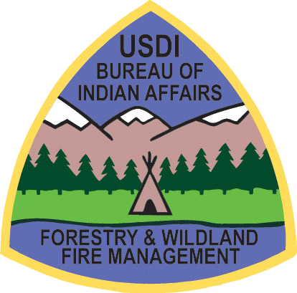
What is the BIA Office of Trust Services

Pathways Internship Program

The BIA, Office of Trust Services Pathways Internship Program works to recruit, hire, develop, and retain high quality Native students for the programs we serve. Once such program is Wildland Fire Management. Through funding provided by the BIA Branch of Wildland Fire Management, Fire interns receive $5,000 in tuition assistance and seasonal employment opportunities working for BIA or tribal wildland fire management programs. In addition to tuition assistance and seasonal employment, upon graduation, BIA may place graduates directly into a career position within the BIA without competition.
To complete the Program, interns must accrue 640 hours of field experience. Their end-goal is to certify as an advanced firefighter (FFT1), which typically takes three to four summers. After completing the internship, firefighters’ job positions will change to forest technician (fire) as they move into a permanent BIA or tribal position Learn more about successful student interns here.
https://www.facebook.com/BIAFireForestry/ https://twitter.com/BIAFireForestry

Salish Kootenai College (SKC)
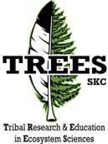
SKC provides higher learning opportunities for students interested in pursuing degrees in natural resources, forestry or wildland fire management. SKC is currently the only tribal college in the nation that provides Bachelor of Science degrees emphasizing Forestry or Wildland Fire Management. Consequently, the BIA Student Internship Program partners with the Salish Kootenai College Center for Tribal Research and Education in Ecosystem Sciences (TREES) to administer the BIA Forestry/Wildland Fire Internships. While Student Interns do not have to attend SKC to participate in the Internship Program, students that do get the advantage of living in college dorm rooms while working on one of the many progressive fire crews managed by the Confederated Salish Kootenai Tribes.
www.facebook.com/skctrees

Fire Internship Program Coordinator
Full details about eligibility and the application process are available on the Workforce Planning and Coordination Office Supporting Natural Resources and Tribal Youth Programs Web page. For questions about the Wildland Fire Student Internships, contact the Fire Internship Program Coordinator, Craig Cook at treesfire@skc.edu or call 208.761.8653.

